**11. ReactJS-HOL**

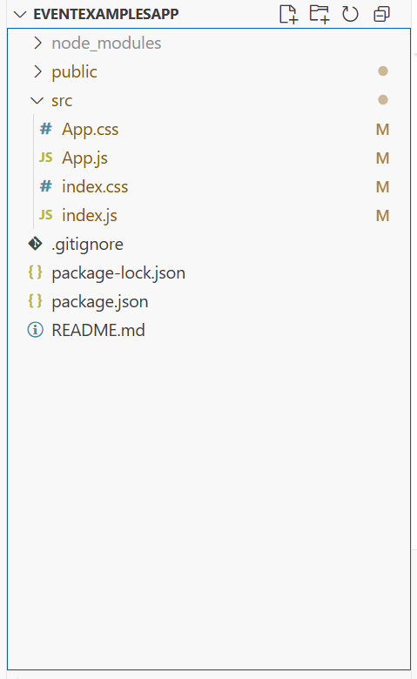

**Index.js**import React from "react";

import ReactDOM from "react-dom/client";

import "./index.css";

import App from "./App";

const root = ReactDOM.createRoot(document.getElementById("root"));

root.render(<App />);

**App.js**

import React, { useState } from "react";

import "./App.css";

function App() {

const [count, setCount] = useState(5);

const [amount, setAmount] = useState("");

const [currency, setCurrency] = useState("");

// Increment and say Hello

const handleIncrement = () => {

setCount(count + 1);

alert("Hello! Member1");

};

// Decrement

const handleDecrement = () => {

setCount(count - 1);

};

// Say welcome

const sayMessage = (msg) => {

alert(msg);

};

// Synthetic event

const handleSyntheticClick = (e) => {

e.preventDefault();

alert("I was clicked");

};

// Currency conversion

const handleSubmit = (e) => {

e.preventDefault();

let convertedValue = 0;

if (currency.toLowerCase() === "euro") {

convertedValue = amount * 80; // Example: 1 Euro = ₹80

alert(`Converting to Euro Amount is ${convertedValue}`);

} else if (currency.toLowerCase() === "inr") {

convertedValue = amount / 80;

alert(`Converting to Rupees Amount is ${convertedValue}`);

} else {

alert("Please enter a valid currency: Euro or INR");

}

};

return (

<div className="container">

<h3 className="header">React App</h3>

<p className="counter">{count}</p>

<div className="buttons">

<button onClick={handleIncrement}>Increment</button>

<button onClick={handleDecrement}>Decrement</button>

<button onClick={() => sayMessage("welcome")}>Say welcome</button>

<button onClick={handleSyntheticClick}>Click on me</button>

</div>

<h2 className="title">Currency Convertor!!!</h2>

<form onSubmit={handleSubmit} className="form">

<div className="form-group">

<label>Amount:</label>

<input

type="number"

value={amount}

onChange={(e) => setAmount(e.target.value)}

required

/>

</div>

<div className="form-group">

<label>Currency:</label>

<input

type="text"

placeholder="Euro / INR"

value={currency}

onChange={(e) => setCurrency(e.target.value)}

required

/>

</div>

<button type="submit" className="submit-btn">Submit</button>

</form>

</div>

);

}

export default App;

**App.css**  
.container {

padding: 20px;

font-family: Arial, sans-serif;

}

.header {

margin: 0;

}

.counter {

font-size: 22px;

margin: 10px 0;

}

.buttons {

margin-bottom: 20px;

}

button {

display: block;

margin: 5px 0;

padding: 8px 12px;

border: none;

background-color: #4CAF50;

color: white;

font-size: 14px;

border-radius: 4px;

cursor: pointer;

}

button:hover {

background-color: #45a049;

}

.title {

color: green;

font-weight: bold;

font-size: 24px;

margin-top: 20px;

}

.form {

margin-top: 15px;

}

.form-group {

margin-bottom: 10px;

}

label {

display: inline-block;

width: 80px;

font-weight: bold;

}

input {

padding: 5px;

width: 200px;

border: 1px solid #ccc;

border-radius: 4px;

}

.submit-btn {

background-color: #007BFF;

}

.submit-btn:hover {

background-color: #0056b3;

}

**index.css**

body {

margin: 0;

padding: 20px;

background-color: white;

}

